

**SHAID SMARAK COLLEGE**

Kirtipur, Kathmandu

*Assignment No. 5 of C programming*

**Submitted by :-**

2nd semester

Amir Maharjan

**Submitted to :-**

Himal Raj Gental

**Q.1 Use array to store grades of a student of 8 subjects and calculate its percentage.**

**Program**

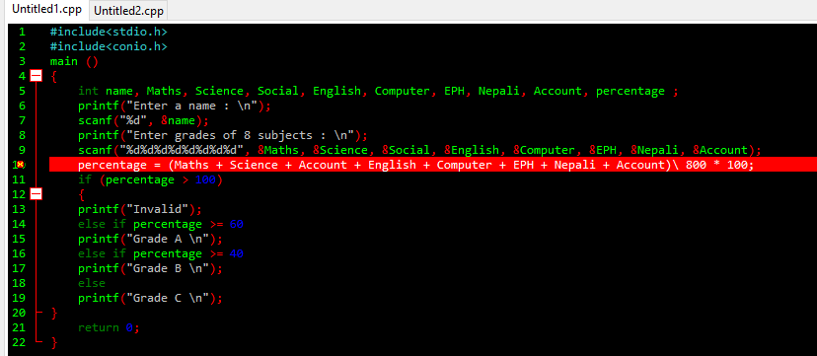

**Output**

**Q.2** Program to count the no. of positive and negative numbers.

Program

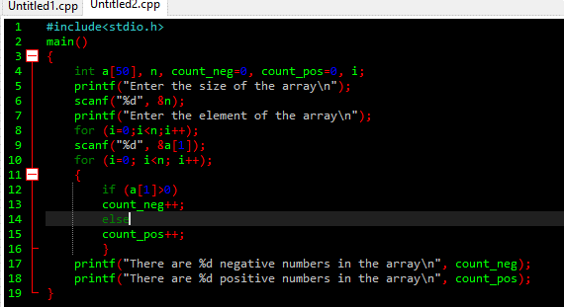

Output

